**Unit 1 Investigation 3**

Name: ____________________________

Period: _____

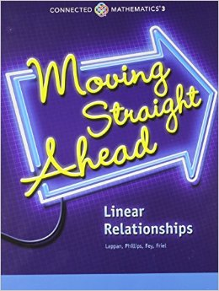

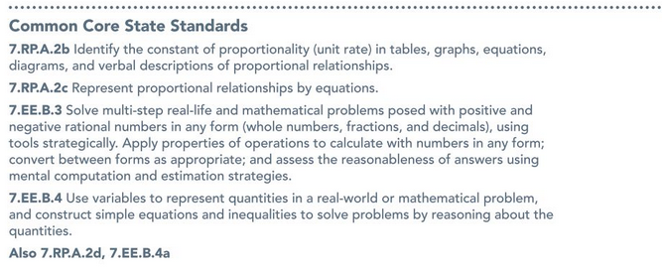

**Investigation 3.1 Notes:**

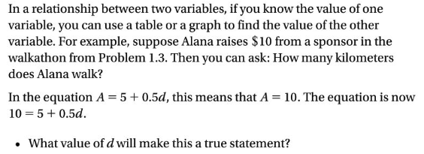

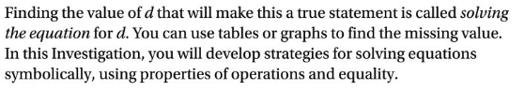

**Problem 3.1:**

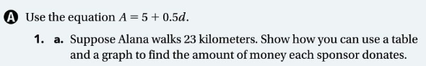

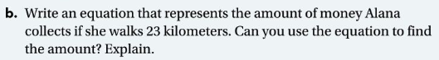

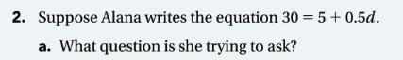

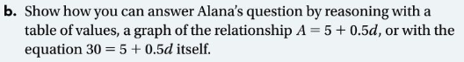

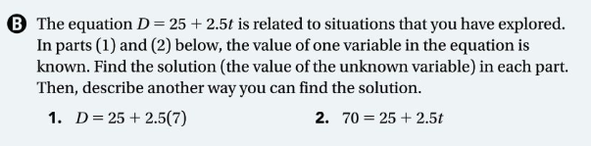

**Investigation 3.2 Notes:**

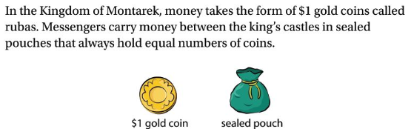

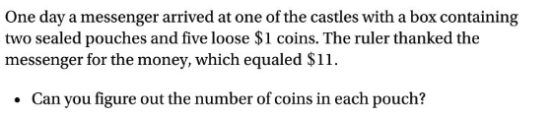

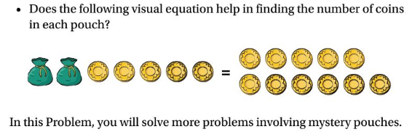

**Problem 3.2:**

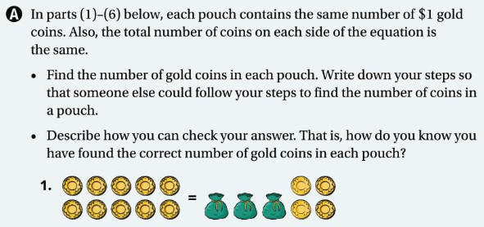

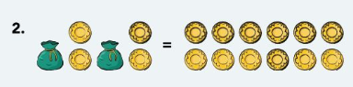

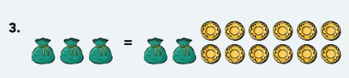

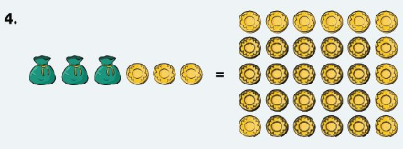

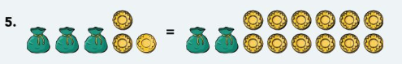

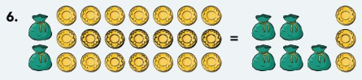

**Problem 3.3:**



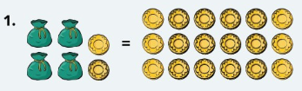

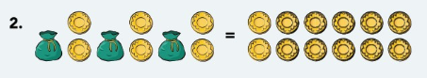

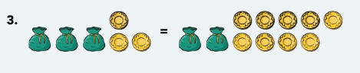



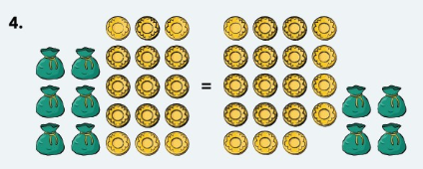



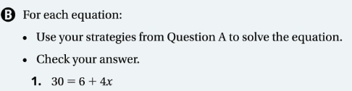

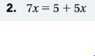





**Investigation 3.4 Notes**

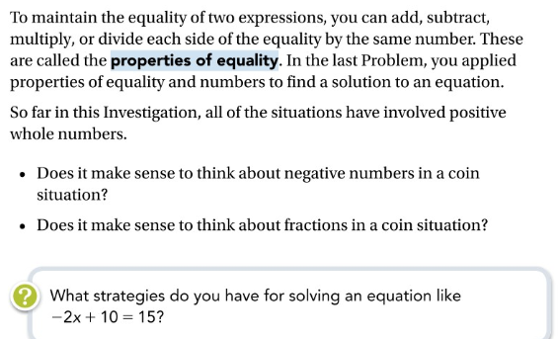

**Problem 3.4**

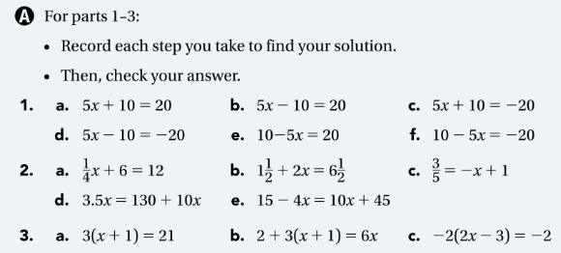

Choose 2 Equations from each row to solve on the next page

Row 1. Equation: Equation:

Row 2. Equation: Equation:

Row 3. Equation: Equation:

Row 4. Equation: Equation:

Row 5. Equation: Equation: